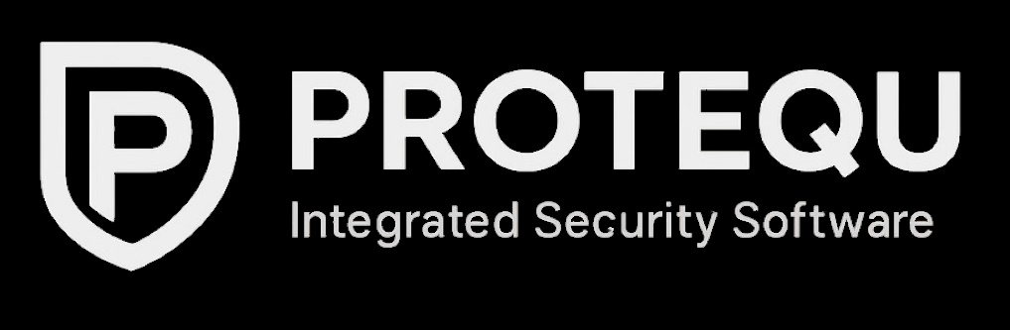

Unifying Physical Security Management

in a Single Intelligent Platform

Open Integration Platform for Unified Security and Infrastructure Management

Supported Technologies
PROTEQU seamlessly integrates and manages all key components of modern physical security and building infrastructure, including:

- Access Control Systems
- Intrusion Detection Systems
- CCTV Surveillance
- Fire Detection and Alarm Systems
- Visitor Management Solutions
- Time and Attendance Systems
- Human Resources Databases
- Perimeter Detection Systems
- Building Automation Devices
- External System Monitoring
- Irrigation Management and Monitoring
- Energy Management and Monitoring

PROTEQU connects, controls, and monitors all these technologies through one unified database and a single intuitive interface

Benefits for Customers
PROTEQU offers a new level of visibility, interoperability, and control across all systems
- Unified Control
Operate all connected security and facility systems from one platform
- Centralized User & Credential Management
Manage access rights and user credentials across all identification-based systems
- Consistent User Interface
One intuitive graphical environment for visualizing and monitoring of all devices
- Comprehensive Reporting
Unified reports and analytics based on flexible, user-defined criteria
- Intelligent Interoperability
Logical communication between all connected systems for advanced automation
- Role-Based Permissions
Operator rights adapted to the organization’s internal structure
- Complete Integration Platform
One management solution uniting all security and infrastructure technologies
- Customization and Dashboards
Tailored views, layouts, and dashboards to meet customer requirements


PROTEQU transforms fragmented technologies into a single, efficient, and intelligent management ecosystem.
Main Characteristics
Protequ’s architecture combines performance, scalability, and openness — built for today and ready for tomorrow.
- Scalability One solution for small, mid-size, and enterprise installations
- Modularity Customers deploy only the modules that fit their needs
- Flexibility Dynamic configuration for single or multi-site operation
- Native PostgreSQL Database Eliminates the cost of third-party database licenses
- NATS.io Messaging Layer Real-time message handling up to 500,000 messages/second
- Open Integration Philosophy Supports devices from any manufacturer worldwide
- Developer-Friendly Open APIs and standard development protocols
- Open Source Foundation Ensures transparency, adaptability and evolution
- OpenID Connect Authentication Modern, secure identity management
- Web-Based Client Application No installation, accessible anytime
- High Level of Cybersecurity Developed following best practices and modern standards

PROTEQU stands at the crossroads of innovation and reliability
A future-proof PSIM solution built to grow with your organization
Protequ s.r.o.
Prague, Czech Republic
🌐 www.protequ.com

+420 777 888 897

info@protequ.com

